Ethereum is a decentralized, open-source blockchain platform that enables developers to build and deploy smart contracts and decentralized applications (DApps).
It uses the Ethereum Virtual Machine (EVM) for executing code and Ether (ETH) as its native cryptocurrency to pay for transaction fees and computation.
The Ethereum Network
Ethereum network is a peer-to-peer (P2P) network.
In this network, nodes participate to maintain the blockchain and take part in the consensus mechanism.
The Ethereum network ensures that all nodes have the same copy of data and remain synchronized.
Based on requirements and usage, the Ethereum network is divided into three main types: Mainnet, Testnet, and Private Net.

1. Mainnet
Mainnet is the current live and production network of Ethereum.
All real transactions and smart contracts are executed on the Mainnet.
It is the network where actual Ether (ETH) has real monetary value.
The current version of Mainnet is called Byzantium (Metropolis).
The Chain ID of the Ethereum Mainnet is 1.
Chain ID is used to uniquely identify the network and avoid replay attacks between different networks.
A Block Explorer for Ethereum is available at https://etherscan.io.
Etherscan allows users to view detailed information about blocks, transactions, and other metrics on the blockchain.
Thus, Mainnet is the live environment where all production-level smart contracts are deployed.
2. Testnet
Testnet is also known as Ropsten, which is the widely used test network for the Ethereum blockchain.
It is used for testing smart contracts and DApps before deploying them on the Mainnet.
Since Testnet uses test Ether, developers can experiment without using real money.
This network helps in research, experimentation, and debugging of blockchain applications.
The main Testnet is called Ropsten, and it contains all the features of other smaller test networks.
Other popular Testnets include Kovan and Rinkeby, which were created for testing Byzantium releases.
All the improvements and features from Kovan and Rinkeby have now been merged into Ropsten.
Hence, the Ropsten Testnet now includes all the properties and functionalities of Kovan and Rinkeby.
The Chain ID of Ropsten is 3, Rinkeby is 4, and Kovan is 42.
Testnets are mainly used by developers for safe contract deployment and testing before moving to the Mainnet.
Private Net
A Private Net is a custom Ethereum network created by generating a new genesis block.
It is not connected to the public Mainnet or Testnet.
This type of network is used when a private group of organizations or individuals wants to run their own blockchain.
Private networks are generally used in enterprise blockchain solutions or research projects.
It allows permissioned access, meaning only authorized participants can join and validate transactions.
Private nets are also useful for testing and development in isolated environments.
Thus, a Private Net gives full control over configuration, consensus rules, and participants.

4. Network IDs / Chain IDs
Each Ethereum network has a unique Network ID or Chain ID used by Ethereum clients to identify the network.
These IDs prevent transaction replay between different networks.
Below is the list of commonly used Ethereum network IDs:
Network Name | Network ID / Chain ID
Ethereum Mainnet | 1
Morden (old testnet) | 2
Ropsten (testnet) | 3
Rinkeby (testnet) | 4
Kovan (testnet) | 42
Ethereum Classic Mainnet | 61
Each Chain ID helps Ethereum clients recognize which blockchain they are connected to.

5. Summary
The Ethereum network consists of three types — Mainnet, Testnet, and Private Net.
Mainnet is the live network for real Ether transactions.
Testnet is used for development and testing of smart contracts and DApps.
Private Net is a custom blockchain for private or internal use.
Each network has a unique Chain ID for identification and separation.
The Etherscan block explorer helps in monitoring and exploring Ethereum blockchain data.

The Ethereum ecosystem is made up of several components that work together to make the network function.
It includes the blockchain, nodes, clients, smart contracts, accounts, and tools that help users interact with the system.
Each component has a special role in maintaining, securing, and using the Ethereum network.

Components of Ethereum Ecosystem
1. Ethereum Blockchain
Ethereum blockchain is the core component of the ecosystem.
It is a distributed, decentralized ledger that records all transactions and smart contract executions.
Each block in the Ethereum blockchain contains verified transactions, the previous block hash, and a block header.
All blocks are linked together cryptographically, ensuring immutability and transparency.
The blockchain runs on thousands of peer-to-peer nodes spread across the world.

2.Ethereum Client (Example: Geth)
An Ethereum client is a software application that connects a node to the Ethereum network.
The most commonly used Ethereum client is Geth (Go-Ethereum).
Geth allows a computer to act as a full node — downloading the blockchain, validating transactions, and mining new blocks.
It also provides functionalities like account management, mining operations, and interaction with smart contracts.
The local copy of the blockchain is synchronized regularly with the network

3. Web3.js Library
Web3.js is a JavaScript library used to interact with the Ethereum blockchain from web applications.
It allows developers to communicate with the Ethereum client (like Geth) through an RPC (Remote Procedure Call) interface.
Using Web3.js, a web application can send transactions, deploy smart contracts, and read blockchain data directly from a browser.
It acts as a bridge between front-end applications and the Ethereum network.

4. Keys and Addresses
Keys and addresses are used to represent ownership and identity in Ethereum.
Each user has a private key and a public key.
The private key is secret and is used to sign transactions, while the public key is derived from it.
An address is derived from the public key — it is a 20-byte (160-bit) identifier that uniquely represents an account.
The address is used to send or receive Ether and interact with contracts.

5.Accounts
Accounts are fundamental elements of Ethereum that hold Ether and interact through transactions.
Ethereum has two types of accounts —
(1) Externally Owned Accounts (EOAs) controlled by private keys, and
(2) Contract Accounts (CAs) controlled by smart contract code.
EOAs can initiate transactions, while CAs execute code when triggered by transactions or messages.
Accounts maintain four key fields — nonce, balance, storage root, and code hash.
Accounts
Accounts are the basic units of state in the Ethereum blockchain.
They hold balances, nonce values, storage roots, and code hashes.
There are two types of accounts in Ethereum:
- Externally Owned Accounts (EOA)
- Contract Accounts (CA)
Externally Owned Accounts (EOAs):
They are controlled by private keys and can send transactions.
They hold Ether balance but have no code associated with them.
They represent real users on the Ethereum network.
Contract Accounts (CAs):
They contain smart contract code and Ether balance.
They are not controlled by private keys but by program logic stored in the blockchain.
They execute code when triggered by a transaction or another contract.
Both EOAs and CAs contribute to state transitions in Ethereum when transactions occur.

6. Transactions and Messages
A transaction is a digitally signed data packet that initiates a change in the blockchain state.
Transactions are created by Externally Owned Accounts.
There are two types of transactions:
- Message Call Transaction – sends data or value to another account or contract.
- Contract Creation Transaction – deploys a new smart contract on the blockchain.
Each transaction includes fields like nonce, gas price, gas limit, to, value, data, and signature (v, r, s).
Transactions are verified by the network, executed in the EVM, and stored in blocks.
Messages are similar to transactions but are internal calls between contracts.
They contain sender, receiver, data, value, and gas limit fields.
Messages do not appear on the blockchain directly; they exist only during execution.

7. Ether (ETH) – The Cryptocurrency
Ether is the native cryptocurrency of the Ethereum network.
It is used to pay for computational work and transaction fees (called gas).
Ether also serves as a medium of exchange for transferring value between accounts.
Every operation in Ethereum requires gas, which prevents spam and rewards miners for their work.

8. Ethereum Virtual Machine (EVM)
The Ethereum Virtual Machine is a decentralized computation engine that executes smart contracts.
It ensures that the same code produces the same results on every node (deterministic execution).
EVM isolates contract execution from the physical hardware to maintain security and consistency.
Each node runs the EVM to process transactions and update the blockchain state.

9. Smart Contracts
Smart contracts are self-executing programs stored and run on the Ethereum blockchain.
They contain code and rules that automatically execute when predefined conditions are met.
Smart contracts are written in high-level languages such as Solidity or Vyper and compiled to EVM bytecode.
They enable decentralized applications (DApps) like DeFi, NFTs, and DAOs to function without intermediaries.

Perfect 👍 — here’s a clear, exam-ready explanation of Supporting Protocols in Ethereum, written line by line with topics and subtopics for easy writing in your paper.

Topic: Supporting Protocols in Ethereum Ecosystem
Introduction
- The Ethereum ecosystem aims to achieve a fully decentralized web.
- To make this possible, not only the blockchain but also storage and communication layers must be decentralized.
- Two important supporting protocols that help achieve this goal are Whisper and Swarm.
- These protocols provide decentralized messaging and decentralized storage services.

1. Whisper Protocol
1.1 Overview
- Whisper is a decentralized peer-to-peer messaging protocol developed for Ethereum.
- It enables communication between decentralized applications (DApps) without using any central server.
1.2 Purpose
- The main purpose of Whisper is to provide a secure, private, and censorship-resistant way for DApps to exchange messages.
- It acts as a communication layer of the Ethereum ecosystem.
1.3 Working
- Whisper uses the DEVp2p wire protocol to exchange messages between nodes.
- Messages sent through Whisper are encrypted and routed peer-to-peer across the network.
- It is designed for small data transfers and non-real-time communication.
- Each message has a Time-To-Live (TTL) value, after which it automatically expires.
1.4 Features
- Provides dark communication, meaning it is difficult to trace message senders and receivers.
- Enables anonymous and secure communication between DApps.
- Does not require blockchain consensus, making it cheaper and faster for message exchange.
- Useful in cases where real-time speed is not critical but privacy is important.
1.5 Implementation
- Whisper is already available in the Geth client.
- It can be activated using the command:
geth --shh
- Official documentation is available at:
https://github.com/ethereum/wiki/wiki/Whisper

2. Swarm Protocol
2.1 Overview
- Swarm is a decentralized, distributed, and peer-to-peer storage platform.
- It provides a storage layer for the Ethereum Web3 stack.
2.2 Purpose
- The main purpose of Swarm is to provide decentralized file storage without depending on centralized servers.
- It is designed to make Ethereum fault-tolerant and resistant to censorship or data loss.
2.3 Working
- In Swarm, files are divided into chunks and stored across multiple nodes in the network.
- Each file is identified using a hash of its content (content-addressed).
- Swarm uses the DEVp2p network layer, similar to Whisper, to communicate between nodes.
- The bzz protocol is used by Swarm nodes to perform storage operations.
2.4 Features
- Provides Distributed Denial-of-Service (DDoS) resistance and high availability.
- Ensures data redundancy and fault tolerance — files can still be retrieved even if some nodes go offline.
- Works as the storage backbone for decentralized applications (DApps).
- Integrated natively into the Ethereum Web3 stack.
2.5 Documentation
- Official documentation is available at:
https://swarm-guide.readthedocs.io/en/latest/

3. Relationship Between Ethereum, Whisper, and Swarm
Component | Function
Ethereum | Acts as a decentralized computer (handles state and computation).
Whisper | Provides decentralized communication between DApps.
Swarm | Provides decentralized storage for files and data.

Conclusion
- With the help of Whisper and Swarm, Ethereum moves beyond just decentralized computation.
- It becomes a complete decentralized ecosystem — covering computation, communication, and storage.
- This makes Ethereum a strong foundation for Web 3.0 and decentralized applications.

Would you like me to include a simple labeled diagram (showing Ethereum + Whisper + Swarm together) for this topic too? It’s often asked in 10-mark questions.

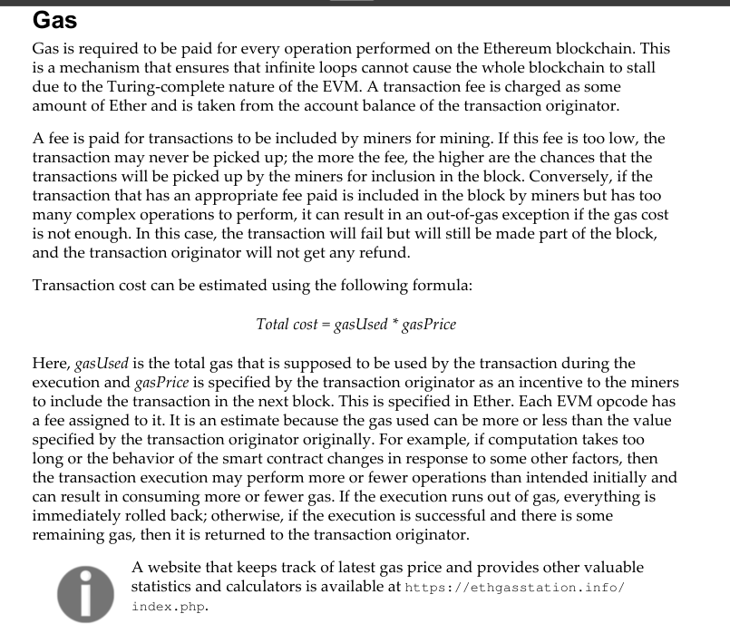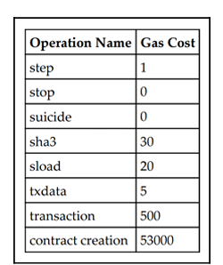

Fee schedule Gas is charged in three scenarios as a prerequisite to the execution of an operation:
The computation of an operation
For contract creation or message call
Increase in the usage of memory

Blocks and Blockchain — Exam Points
A block is the basic unit of data storage in a blockchain and contains a set of transactions and metadata.
An Ethereum block consists of three main parts: the block header, the list of transactions, and the list of ommer (uncle) headers.
The transactions list contains every transaction included in the block in the order they are executed.
The ommers (uncles) list contains headers of recent stale blocks that are referenced for reward and security.
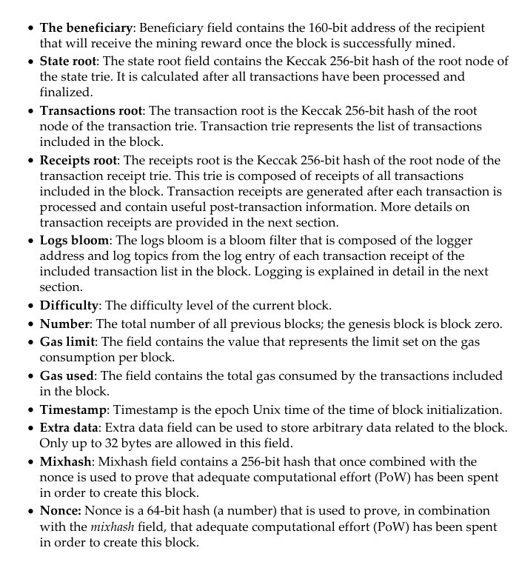

Uncles / Ommers
Uncles (also called ommers) are valid but not-included blocks mined near the same time as main blocks.
Ethereum allows inclusion of up to two uncles per block to reward near-simultaneous miners and improve security.
Including uncles grants the block miner a small bonus and grants the uncle miner a partial reward.
Genesis Block
Genesis Block
The genesis block is the first block of the chain and has no parent hash (all zeros).
The genesis block includes initial state information such as pre-funded accounts and initial parameters.
Genesis is unique for each network (mainnet, testnet, private net) and defines the chain identity.
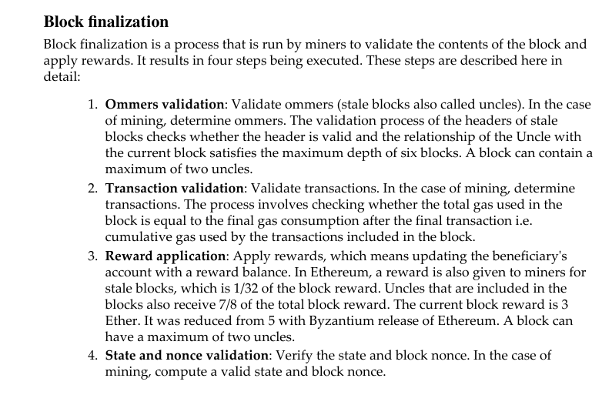

Ethash — Ethereum’s PoW Algorithm (Detailed)
Ethash is the Proof-of-Work algorithm historically used by Ethereum to secure the network.
Ethash evolved from the Dagger-Hashimoto design and is specifically memory-hard to discourage ASIC centralization.
Memory-hardness means miners must perform many memory accesses and therefore benefit from high memory bandwidth.
Ethash depends on a large data structure called the DAG (Directed Acyclic Graph) which miners use as a seed for hashing.
The DAG is regenerated every epoch, where one epoch equals 30,000 blocks (approx. ~5.2 days historically).
The DAG size increases over time and must be generated and stored by miners before efficient mining for the epoch can begin.
Ethash mining attempts require reading pseudo-random subsets of the DAG for each hash attempt, making memory throughput critical.
Because of the DAG requirement, Ethash makes custom ASICs less economically attractive and favors GPU mining.
Mining consists of finding a nonce such that hashing the block header plus nonce produces a value below the current difficulty target.
Ethash uses two header fields — mixHash and nonce — which together prove that sufficient PoW effort was expended.
Network difficulty is adjusted frequently (per block) to target an average block time (historically ~12 seconds).
Ethash makes initial mining feasible on CPUs/GPUs but gradually requires higher resources as DAG and difficulty grow.

Methods of Mining in Ethereum
1. CPU Mining
CPU mining uses the computer’s central processing unit to perform the hashing operations required for Proof-of-Work.
Although CPU mining is not profitable on the mainnet due to high difficulty, it is still valuable for testing and learning purposes.
It is commonly used on private networks or test networks for experimentation with mining and smart contract deployment.
In Ethereum, CPU mining can be done using the Geth (Go Ethereum) client.
Mining can be started from the command line using:
geth --mine --minerthreads <n> where <n> is the number of CPU threads used for mining.
For example, the command miner.start(4) starts mining with 4 CPU threads.
To stop mining, the command miner.stop() is used.
The command returns True if successful.
CPU mining helps beginners understand mining mechanics without expensive hardware.

2. GPU Mining
GPU mining uses Graphics Processing Units instead of CPUs to perform mining computations.
GPUs are much faster than CPUs because they have thousands of cores optimized for parallel computation.
Ethereum supports GPU mining through the Ethminer software.
Before starting, the Geth client must be running and fully synchronized with the Ethereum blockchain using the command:
geth --rpc
Once Geth is running, Ethminer is used to start GPU mining using:
ethminer -G
Here, the -G flag tells Ethminer to use GPU hardware.
If no compatible GPU is found, Ethminer will show an error message.
GPU mining requires a compatible AMD or NVIDIA graphics card and the correct OpenCL SDK installed.
For NVIDIA GPUs, the CUDA toolkit is downloaded from https://developer.nvidia.com/cuda-downloads.
For AMD GPUs, the OpenCL SDK is available from http://developer.amd.com/tools-and-sdks/opencl-zone/amd-accelerated-parallel-processing-app-sdk.
Once configured correctly, GPU mining can start immediately using the above command.
GPU mining is more profitable and efficient than CPU mining due to higher hash rates.

3. Benchmarking
Benchmarking helps to test and measure mining performance before starting actual mining.
Ethminer can perform both CPU and GPU benchmarking using simple commands.
For CPU benchmarking, the command is:
ethminer -M -C
For GPU benchmarking, the command is:
ethminer -M -G
These commands measure the hash rate performance of the CPU or GPU, respectively.
Specific GPU devices can be selected using the command:
ethminer -M -G --opencl-device 1
Benchmarking helps miners identify the most efficient hardware and optimize settings.
AMD GPUs generally perform better than NVIDIA GPUs for Ethereum mining due to better OpenCL optimization.
Because Ethash (Ethereum’s PoW algorithm) is memory-hard, FPGAs and ASICs offer no major advantage over GPUs.
This is intentional to discourage centralization through specialized mining hardware.

4. Mining Rigs
As Ethereum’s mining difficulty increased, miners began building dedicated mining rigs.
A mining rig is a computer system with multiple GPUs working together to increase mining power.
Typically, a rig has 5–6 GPUs connected to a single motherboard.
Each GPU works in parallel, improving the chances of finding valid nonces for blocks.
Mining rigs can be built manually or purchased commercially.
A standard mining rig includes the following key components:
- Motherboard: Must support multiple GPU connections (for example, ASRock H81 or BIOSTAR Hi-Fi).
- SSD Hard Drive: Provides faster read/write speeds; at least 250 GB of free space is recommended for blockchain storage.
- GPUs: The most critical component, such as AMD Radeon R9 380 with 4 GB RAM.
- Operating System: Linux (especially Ubuntu or EthOS) is preferred for better performance and stability.
- Mining Software: Includes Geth and Ethminer for running mining operations.
- Cooling System: Essential to prevent overheating since GPUs generate significant heat during mining.
- Power Supply Unit (PSU): A high-power PSU (around 1000 watts) is needed to support multiple GPUs.
EthOS is a specialized Linux distribution designed for Ethereum mining that provides easy configuration and remote monitoring.
Proper cooling and monitoring software are essential to prevent hardware failures and maintain efficiency.

5. Mining Pools
As mining difficulty increased, solo mining became less profitable.
To increase the chances of earning rewards, miners join mining pools where computational power is shared.
A mining pool combines the hash rates of multiple miners to mine blocks faster.
When a block is mined successfully, the reward is divided among participants according to their contribution.
Ethminer can connect to mining pools using a URL provided by the pool.
For example, the command for connecting to a pool is:
ethminer -C -F http://ethereumpool.co/?miner=0.1@0x024a20cc5feba7f3dc3776075b3e61234eb1459c@DrEquinox
Each pool has its own connection URL and configuration details.
When connected, Ethminer downloads work packages and submits solutions back to the pool.
Mining pools make mining more predictable and reduce the risk of long gaps between rewards.

